

HPE OneView Ansible Collection Installation and User Guide

**Table of Contents**

Preface 3

Installation of Ansible Collection …………………………………………………………………………………………………………………………………………………………………….…………………………….4

Installation of HPE OneView Modules 4

Install HPE OneView collection from GitHub…………………………………………………………………………………..5

Install HPE OneView collection from Ansible Galaxy…………………………………………………………………………………………………………………………………………………………………..5

Install HPE OneView collection dependency packages……………………………………………………………………………………………………………………………………………………………… 5

Install HPE OneView collection from Docker Image……………………………………………………………………………………………………………………………………………………………………. 5

Running the Playbooks………………………………………………………………………………………………………………………………………………..…………………………………………….. 5

## Examples Playbooks provided with Ansible HPE OneView module…………………………………………………………… 6

Convert custom HPE OneView module playbooks to Ansible Collection [2.10]…………………………………. 6

Developing new playbook in the HPE OneView Ansible Collection module……………………………………………………………………………………………………………………………………………………….. 7

Appendix

**Preface**

The **Install and User Guide of Ansible Collection for HPE OneView** can help move current customers from the legacy Ansible module to the new Ansible collection. This will enable customers to take full advantage of infrastructure automation using Ansible collection modules, in addition to helping improve the customer experience.

This guide covers various aspects including installation of Ansible collection, installation of HPE OneView Ansible Collection, and running the Ansible playbooks. This guide also provides step-by-step details to the customer for adopting, moving, and migrating to HPE OneView Ansible Collection in each of the following sections.

Installation of Ansible collection

Installation of HPE OneView Ansible Collection SDK

Running the playbooks

Examples provided in the HPE OneView Ansible Collection

Conversion of existing custom Ansible playbooks to Ansible collection playbooks.

Developing new Ansible collection playbooks.

**Technical aspects**

**Checklist**

For leveraging HPE OneView Ansible Collection SDK module, the requirement is to have **Ansible module >= 2.9 installed**. And uninstall the Ansible module < 2.9 from the DevOps appliance / OS if exists.

Python requirements: Ansible collection works with both Python versions 2.7.9 and 3.6.x—preferably Python 3.6.x version.

The file structure of the Ansible collection project is different from the Ansible project. The following is the screenshot of Ansible project structure.

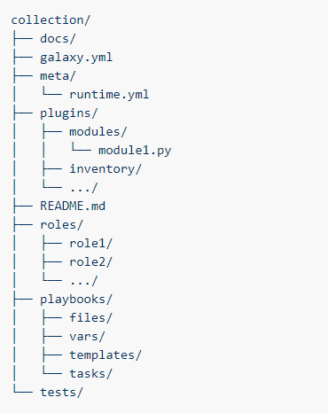

Figure 1. Ansible collection structure

Reusable scripts from existing HPE OneView Ansible module:

(a) Python scripts from oneview-ansible/library: Python scripts from library module are moved to oneview-ansible-collection/plugins/ directory.

(b) Tasks scripts from oneview-ansible/examples/yaml files are moved to oneview-ansible-collection/roles directory.

We use the ansible-galaxy executable to create the appropriate collection project structure.

ansible-galaxy collection init oneview_custom_collection_use_case

## 

## Installation of Ansible collection

**Requirements**

1. As part of using the new Ansible collection in the DevOps appliance, we will need to first uninstall the existing/old Ansible module if an installed version exists and is < 2.9.
2. Download and install the Ansible >= 2.9 version from [**Red Hat® portal**](https://access.redhat.com/) .
3. HPE OneView Python SDK (<https://pypi.org/project/hpeOneView/>)

## Installation of HPE OneView Ansible Collection:

The HPE OneView Ansible Collection includes roles, modules, sample playbooks, and module_utils. We can install HPE OneView Ansible Collection modules through multiple ways as listed in the following table.

Table 1.Download locations for HPE OneView Ansible Collection

|  |  |  |  |  |
| --- | --- | --- | --- | --- |
| Repositories | [**HPE GitHub**](https://github.com/HewlettPackard/oneview-ansible-collection) | [**Ansible Galaxy**](https://galaxy.ansible.com/hpe/oneview) | [**Ansible Automation Hub**](https://www.ansible.com/products/automation-hub) | [**Docker Image**](https://hub.docker.com/repository/docker/hewlettpackardenterprise/hpe-oneview-sdk-for-ansible-collection) |
| **Ansible HPE OneView Collection** | Open Source  Community Project | Community Portal  Ansible Galaxy provides pre-packaged units of work known to Ansible as roles and collections. | Red Hat Subscription  And Support  Ansible certified content backed by Red Hat and HPE. | Open Source  The containerized version of the GitHub oneview-ansible-collection module is available in the Docker Store. |

**Install HPE OneView collection from GitHub**

<https://github.com/HewlettPackard/oneview-ansible-collection>

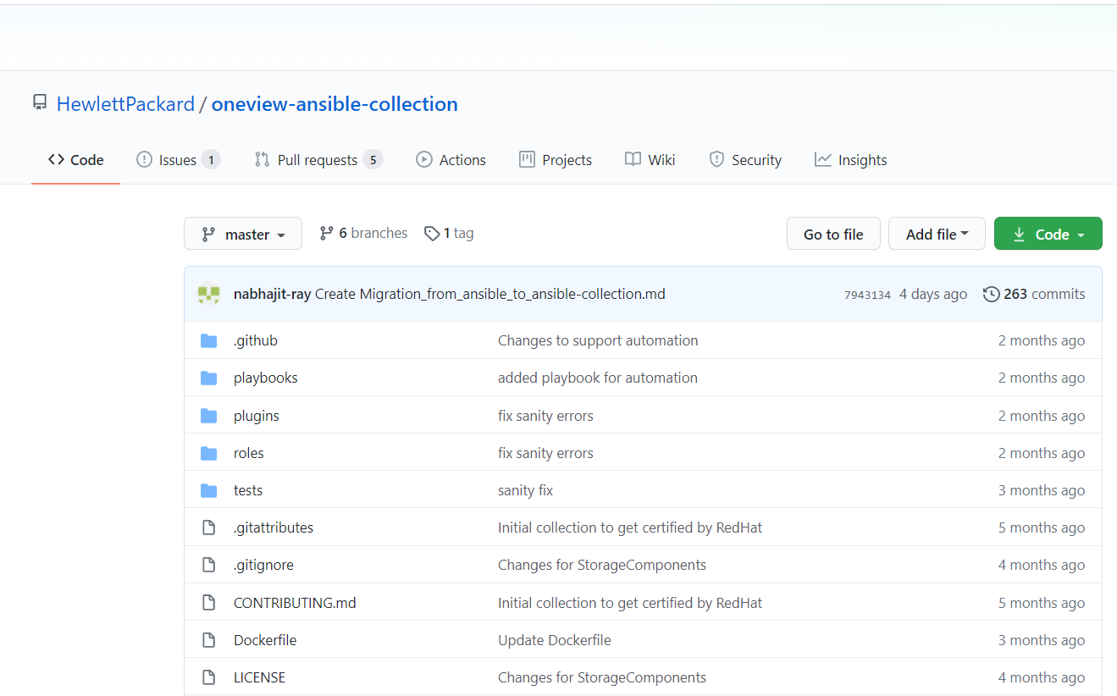

**Figure 2. HPE OneView Ansible Collection GitHub Repository**

$ git clone <https://github.com/HewlettPackard/oneview-ansible-collection.git>

$ cd oneview-ansible-collection

$ ansible-galaxy collection build

The build process will create hpe.oneview in tar file format.

$ ansible-galaxy collection install hpe.oneview

**Install HPE OneView collection dependency packages**

Run the following command to install HPE OneView collection dependency packages:

$ pip install -r requirements.txt

**Installation HPE OneView Ansible collection from Ansible Galaxy**

The HPE OneView Ansible Collection can be installed using Ansible Galaxy. Content from roles and collections can be referenced in Ansible playbooks and immediately put to work.

Installing collections with ansible-galaxy is only supported in Ansible version >= 2.9.

<https://galaxy.ansible.com/hpe/oneview>

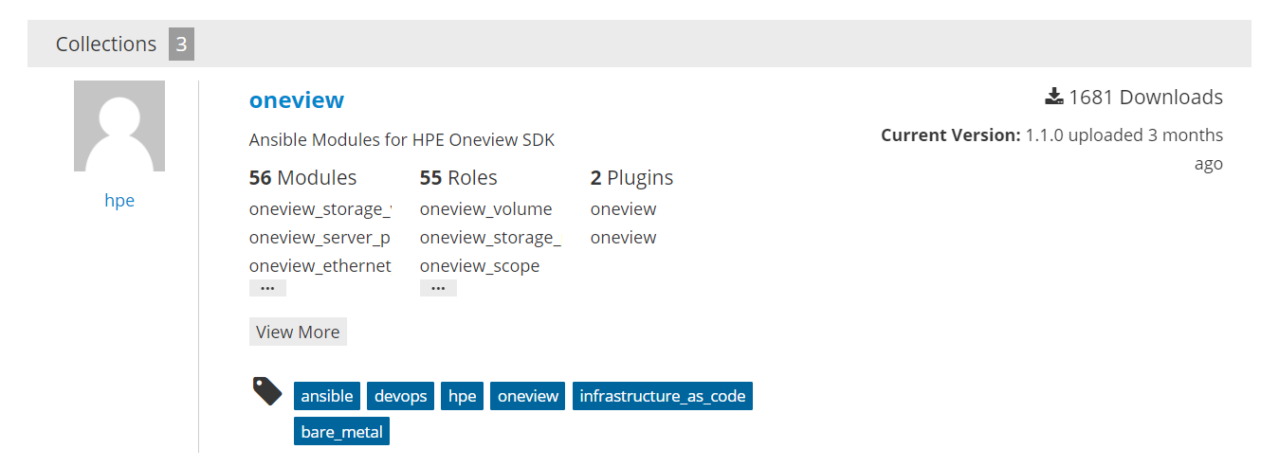

Figure 3. HPE OneView Ansible Collection Ansible Galaxy

To install HPE OneView collection hosted in Galaxy:

$ ansible-galaxy collection install hpe.oneview

Run the following command for upgrading HPE OneView Ansible Collection to the latest version of HPE OneView:

$ ansible-galaxy collection install hpe.oneview –force

**Install HPE OneView collection dependency packages**

Run the following command to install HPE OneView collection dependency packages:

$ pip install -r requirements.txt

**Installation HPE OneView Ansible collection from Red Hat Automation Hub**

The HPE OneView Ansible Collection can be installed using Red Hat Automation Hub. We may want to leverage Automation Hub for downloading and using the HPE OneView collection module certified by Red Hat. At a high level, Automation Hub provides Ansible-certified, -supported content by HPE and Red Hat.

Automation hub is available as software-as-a-service (SaaS) offering to existing Red Hat Ansible Automation Platform customers and can be accessed via [https://cloud.redhat.com](https://cloud.redhat.com/). To consume content from hub as part of your automation workflows can also be accessed via CLI. Hub content can be accessed via CLI, as part of your automation workflows. For this, an offline token is required, which can be obtained via the web UI at <https://cloud.redhat.com/ansible/automation-hub/token>.

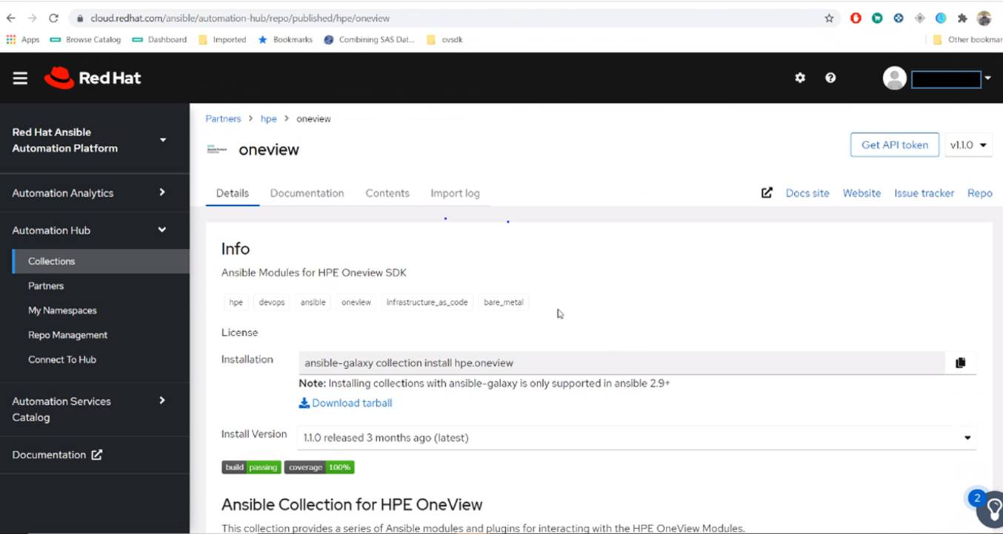

Figure 4. HPE OneView Ansible Collection Red Hat Automation Hub

URL and token needs to be added to the configuration file as follows:

[galaxy]

server_list = automation_hub, galaxy

[galaxy_server.automation_hub]

url=https://cloud.redhat.com/api/automation-hub/

auth_url=https://sso.redhat.com/auth/realms/redhat-external/protocol/openid-connect/token

token=AABBccddeeff112233gghh

[galaxy_server.galaxy]

url=https://galaxy.ansible.com/

Run the following command for installing HPE OneView Ansible Collection from the Automation Hub using the previously mentioned

configuration file.

$ ansible-galaxy collection install hpe.oneview:1.0.3

Note: Automation Hub supports versioning, enabling users to specify the version. Visit the following link for the steps on Automation Hub: [ansible.com/blog/getting-started-with-automation-hub](https://www.ansible.com/blog/getting-started-with-automation-hub)

**Install HPE OneView collection from Docker image**

The containerized version of the oneview-ansible-collection module is available in the [**Docker Hub**](https://hub.docker.com/repository/docker/hewlettpackardenterprise/hpe-oneview-sdk-for-ansible-collection) built on top of Ubuntu OS with prebuilt Python and Ansible environments.

Run the following commands to install HPE OneView collection from Docker mage.

docker build -t oneview-ansible-collections

docker run -it --rm -v (pwd)/:/root/oneview-ansible-collections oneview-ansible-collections

That’s it. To modify any role, simply modify role and rerun the image.

## Running the playbooks

To use a module from HPE OneView collection, we need to reference the full namespace, collection name, and modules name that customers want to use:

$ cd ~/.ansible/collections/ansible_collections/hpe/oneview

Run the ansible-test sanity to make sure the build passes all sanity tests.

Visit the following link for more information on the ansible sanity test options: <https://docs.ansible.com/ansible/latest/dev_guide/testing_sanity.html>

$ ansible-test sanity

$ cd playbooks

Add roles in sample or example.yml file to be used while running the playbook.

(hpe.oneview.oneview_fc_network)---> hpe/oneview/roles/oneview_fc_network/tasks/main.yml

---

- name: Using HPE OneView collection

hosts: all

collections:

- hpe.oneview

roles:

- hpe.oneview.oneview_fc_network

- hpe.oneview.oneview_fc_network_facts

$ ansible-playbook example.yml

## Examples playbooks provided with HPE OneView Ansible Collection

Multiple examples are provided with the HPE OneView Ansible Collection covering all the HPE OneView key resource endpoints such as networks, LIG, EG and LE, server profile template, server profile, HPE Image Streamer, and others. This is to help customers and partners for seamless migration.

**Repository path of examples:**

Let us consider a key resource HPE OneView server profile that is very frequently used for server deployment.

oneview_server_profile example directory in the repo such as <https://github.com/HewlettPackard/oneview-ansible-collection/tree/master/roles>, follows the Ansible collection file structure.

It consists of the key files such as oneview_server_profile/tasks/main.yml, oneview_server_profile/files/oneview_config.json, oneview_server_profile/defaults/main.yml, oneview_server_profile/meta/main.yml, oneview_server_profile/vars/main.yml,

oneview_server_profile/tasks/main.yml and consists of various tasks (ansible code) for creating a server profile, updating server profile, and deleting server profile.

HPE OneView configuration parameters such as host name, IP address, and password are read from oneview_server_profile/files/oneview_config.json.

Parameter values are read from oneview_server_profile/defaults/main.yml and oneview_server_profile/vars/main.yml. Parameter values from /vars/main.yml will take precedence compared to /defaults/main.yml.

oneview_server_profile/meta/main.yml is meant for version and author information.

## Convert custom HPE OneView Ansible Module playbooks to HPE OneView Ansible Collection (2.10)

The file structure of the Ansible collection project is different from the Ansible project.

See the Technical Aspects section for more details and the screenshot of Ansible project structure. As part of conversion of custom HPE OneView module playbooks to Ansible collection, we would be leveraging the Task scripts from existing HPE OneView Ansible module. Respective Task scripts from oneview-ansible/examples/yaml files are moved to oneview-ansible-collection/roles directory.

**Step 1: Creating a collection skeleton for the custom playbook**

To start a custom collection:

$ cd ~/.ansible/collections/ansible_collections/hpe/oneview

$ cd roles/

$ ansible-galaxy collection init oneview_custom_collection_use_case

Once the skeleton is created, add the content to the collection. The skeleton consists of the following subfolders:

oneview_custom_collection_use_case/tasks/main.yml

oneview_custom_collection_use_case/files/oneview_config.json

oneview_custom_collection_use_case/defaults/main.yml

oneview_custom_collection_use_case/meta/main.yml

oneview_custom_collection_use_case/vars/main.yml

**Step 2: Adding the content**

1. Add the Ansible tasks related code in oneview_custom_collection_use_case/tasks/main.yml

Custom HPE OneView module Task scripts from oneview-ansible/examples/yaml files are moved to oneview-ansible-collection/roles directory. If custom HPE OneView module has Python scripts in the oneview-ansible/library, they need to be moved to oneview-ansible-collection/plugins/ directory.

1. Add the HPE OneView configuration such as host name, IP address, and password to oneview_custom_collection_use_case/files/oneview_config.json.
2. Parameter values used in the tasks are read from oneview_custom_collection_use_case/defaults/main.yml and oneview_custom_collection_use_case/vars/main.yml. Populate the parameter values into /defaults/main.yml and /vars/main.yml based on the requirement.
3. Note that parameter values in the /vars/main.yml take precedence when compared to /defaults/main.yml.
4. oneview_custom_collection_use_case/meta/main.yml is meant for meta info like version, author, tags, and such. Fill the version information and author details.

**Step 3: Build the collection**   
To build the collection, run ansible-galaxy collection build from inside the root directory of the collection.

collection_dir#> ansible-galaxy collection build

$ cd ~/.ansible/collections/ansible_collections/hpe/oneview

$ ansible-galaxy collection build

This creates a group of files collected together as one of the built collection in the current directory.

**Step 4: Running the playbook**

Run the ansible-test sanity to make sure the build passes all sanity tests.

$ ansible-test sanity

$ cd playbooks

Create a sample or example oneview_custom_collection_use_case.yml file to be used for running the playbook in the following playbooks’ directory.

Add the respective roles to the sample (or) example playbook oneview_custom_collection_use_case.yml as shown in the following:

---

- name: Using HPE OneView collection oneview_custom_collection_use_case

hosts: all

collections:

- hpe.oneview

roles:

- hpe.oneview.oneview_custom_collection_use_case.yml

**Step 5: Run the playbook as shown in the following**

$ ansible-playbook oneview_custom_collection_use_case.yml

## 

## Developing new playbook in the HPE OneView Ansible Collection module:

**Step 1: Creating a collection skeleton for the new playbook**

To start a new collection:

$ cd ~/.ansible/collections/ansible_collections/hpe/oneview

$ cd roles/

$ ansible-galaxy collection init oneview_new_collection_use_case

Once the skeleton is created, add the content to the collection. The skeleton consists of the following subfolders:

oneview_new_collection_use_case/tasks/main.yml

oneview_new_collection_use_case/files/oneview_config.json

oneview_new_collection_use_case/defaults/main.yml

oneview_new_collection_use_case/meta/main.yml

oneview_new_collection_use_case/vars/main.yml

**Step 2: Adding the content**

1. Add the ansible tasks related content in oneview_new_collection_use_case/tasks/main.yml

2. Add the HPE OneView configuration such as host name, IP address, and password to oneview_new_collection_use_case/files/oneview_config.json.

3. Parameter values used in the tasks are read from oneview_new_collection_use_case/defaults/main.yml and oneview_new_collection_use_case/vars/main.yml. Populate the parameter values into /defaults/main.yml and /vars/main.yml based on the requirement.

4. Note that parameter values in the /vars/main.yml take precedence when compared to /defaults/main.yml.

5. oneview_new_collection_use_case/meta/main.yml is meant for meta info such as version, author, tags, and such. Fill the version information and author details.

**Step 3: Build the collection**   
To build the collection, run ansible-galaxy collection build from inside the root directory of the collection.

collection_dir#> ansible-galaxy collection build

$ cd ~/.ansible/collections/ansible_collections/hpe/oneview

$ ansible-galaxy collection build.

This creates a tar ball of the built collection in the current directory.

**Step 4: Running the playbook**

Run the ansible-test sanity to make sure the build passes all sanity tests.

$ ansible-test sanity

$ cd playbooks

Create a sample or example oneview_new_collection_use_case.yml file to be used for running the playbook in the following playbooks’ directory.

Add the respective roles to the sample (or) example playbook oneview_new_collection_use_case.yml as shown in the following:

---

- name: Using HPE OneView collection oneview_new_collection_use_case

hosts: all

collections:

- hpe.oneview

roles:

- hpe.oneview.oneview_new_collection_use_case.yml

**Step 5: Run the playbook as shown in the following**

$ ansible-playbook oneview_new_collection_use_case.yml

## Summary

Moving from the legacy Ansible module to the new Ansible collection enables the user to take full advantage of infrastructure automation using Ansible collection modules. The new Ansible collection architecture streamlines and focuses Ansible development by providing an updated approach to managing the dramatically increasing volume of related content. By migrating from the HPE OneView Ansible Module to the HPE OneView Ansible Collection, users will ensure full alignment with Ansible’s development path and compatibility with Ansible products.

This document shows that there are multiple paths to migration. That the process is straightforward and can be adjusted to suit a user’s particular circumstances to achieve a seamless migration with limited effort. GitHub, Ansible Galaxy, or Automation Hub, can be used to move and migrate to HPE OneView Ansible Collection. Additionally, converting existing playbooks into playbooks for use with collections is a straightforward process. As is the creation of new customized playbooks for use in the new collection format. Moving from the legacy Ansible module to the new Ansible collection requires limited effort and provides benefits, which make migration a worthwhile investment.

Learn more at

[HPE OneView](https://www.hpe.com/us/en/integrated-systems/software.html)

[HPE OneView Ansible Collection GitHub](https://github.com/HewlettPackard/oneview-ansible-collection)

[Ansible By Red Hat Quick Start Guide](https://www.ansible.com/resources/get-started)

Docker is a trademark or registered trademark of Docker, Inc. in the United States and/or other countries. Red Hat is a registered trademark of Red Hat, Inc. in the United States and other countries. All third-party marks are property of their respective owners.